**Name: Atharva Salitri Division: CSAI B Batch: 2**

**Roll No.: 37 PRN: 12310120**

**Subject: OS Lab Assignment 2**

**Title: Shell Scripts:**

1. **Factorial**
2. **Add two numbers**
3. **Problem Statement: Sorting Algorithms**
4. **Creating File**

touch factorial.sh.

1. **Code:**

#!/bin/bash

echo "Enter a number: "

read num

factorial() {

if [ "$1" -eq 0 ] || [ "$1" -eq 1 ]; then

echo 1

else

echo "$((1 * $1 * $(factorial "$((1 * $1 - 1))")))";

fi

}

result=$(factorial "$num")

echo "The factorial of $num is: $result"

1. **Giving Permission and Running the file**

chmod +x factorial.sh

./factorial.sh

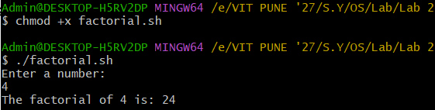

**Add Two Numbers:**

1. **Creating File**

touch add_numbers.sh.

1. **Code:**

#!/bin/bash

add_numbers() {

local sum=$(( $1 + $2 ))

echo "The sum of $1 and $2 is: $sum"

}

if [ $# -eq 2 ]; then

add_numbers "$1" "$2"

else

echo "Enter the first number: "

read num1

echo "Enter the second number: "

read num2

add_numbers "$num1" "$num2"

Fi

1. **Giving Permission and Running the file**

chmod +x add_numbers.sh

./add_numbers.sh 5 10

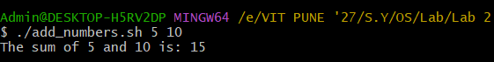

**Problem Statement: Sorting Algorithms**

1. **Creating File**

touch sort_script.sh.

1. **Code:**

#!/bin/bash  
  
bubble_sort() {  
arr=("$@")  
n=${#arr[@]}  
for ((i = 0; i < n-1; i++)); do  
for ((j = 0; j < n-i-1; j++)); do  
if [ ${arr[j]} -gt ${arr[j+1]} ]; then  
temp=${arr[j]}  
arr[j]=${arr[j+1]}  
arr[j+1]=$temp  
fi  
done  
done  
echo "Sorted Array (Bubble Sort): ${arr[*]}"  
}  
  
quick_sort() {  
arr=("$@")  
if [ ${#arr[@]} -le 1 ]; then  
echo "${arr[*]}"  
return  
fi  
pivot=${arr[0]}  
left=()  
right=()  
for i in "${arr[@]:1}"; do  
if [ $i -le $pivot ]; then  
left+=($i)  
else  
right+=($i)  
fi  
done  
echo "$(quick_sort "${left[@]}") $pivot $(quick_sort "${right[@]}")"  
}  
  
selection_sort() {  
arr=("$@")  
n=${#arr[@]}  
for ((i = 0; i < n-1; i++)); do  
min_index=$i  
for ((j = i + 1; j < n; j++)); do  
if [ ${arr[j]} -lt ${arr[min_index]} ]; then  
min_index=$j  
fi  
done  
# Swap  
temp=${arr[i]}  
arr[i]=${arr[min_index]}  
arr[min_index]=$temp  
done  
echo "Sorted Array (Selection Sort): ${arr[*]}"  
}  
  
insertion_sort() {  
arr=("$@")  
n=${#arr[@]}  
for ((i = 1; i < n; i++)); do  
key=${arr[i]}  
j=$((i-1))  
while [ $j -ge 0 ] && [ ${arr[j]} -gt $key ]; do  
arr[$((j+1))]=${arr[j]}  
j=$((j-1))  
done  
arr[$((j+1))]=$key  
done  
echo "Sorted Array (Insertion Sort): ${arr[*]}"  
}  
  
echo "Select a sorting algorithm:"  
echo "1. Bubble Sort"  
echo "2. Quick Sort"  
echo "3. Selection Sort"  
echo "4. Insertion Sort"  
read -p "Enter your choice (1-4): " choice  
  
read -p "Enter numbers in array separated by space: " -a array  
  
case $choice in  
1)  
bubble_sort "${array[@]}"  
;;  
2)  
sorted_array=$(quick_sort "${array[@]}")  
echo "Sorted Array (Quick Sort): $sorted_array"  
;;  
3)  
selection_sort "${array[@]}"  
;;  
4)  
insertion_sort "${array[@]}"  
;;  
*)  
echo "Invalid choice!"  
;;  
esac

1. **Giving Permission and Running the file:**

chmod +x factorial.sh

./sort_script.sh

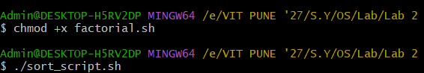

1. **Output:**

